INSTRUCTIONS FOR KX 85-100 KICK STAND
STEAHLY OFF ROAD 541 535 4896
1. Remove the chain roller and bolt located near the left foot peg.
2. If necessary, deburr the inside of bolt hole where the chain roller was mounted to the frame using a round file or the supplied 3/8” drill bit. Make sure the supplied bolt easily fits into the bolt hole.
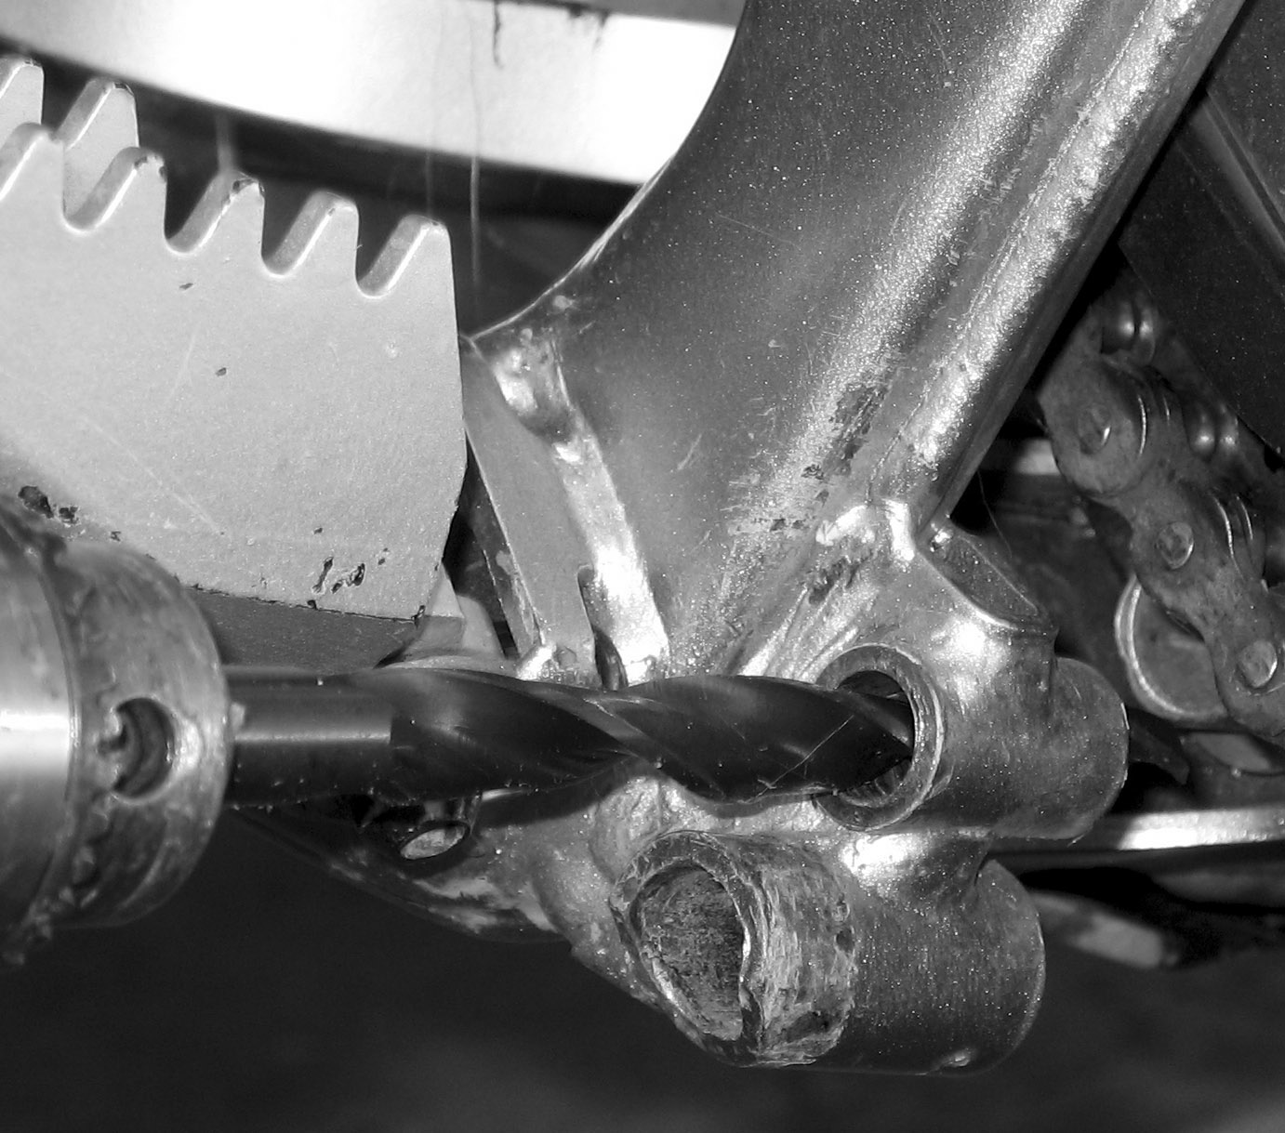
3. If necessary, deburr the inside of the metal chain roller bushing using a round file. Make sure the supplied bolt easily fits into the bushing.
4. Install the kick stand assembly as shown in the picture. The two supplied washers go on each side of the chain roller.
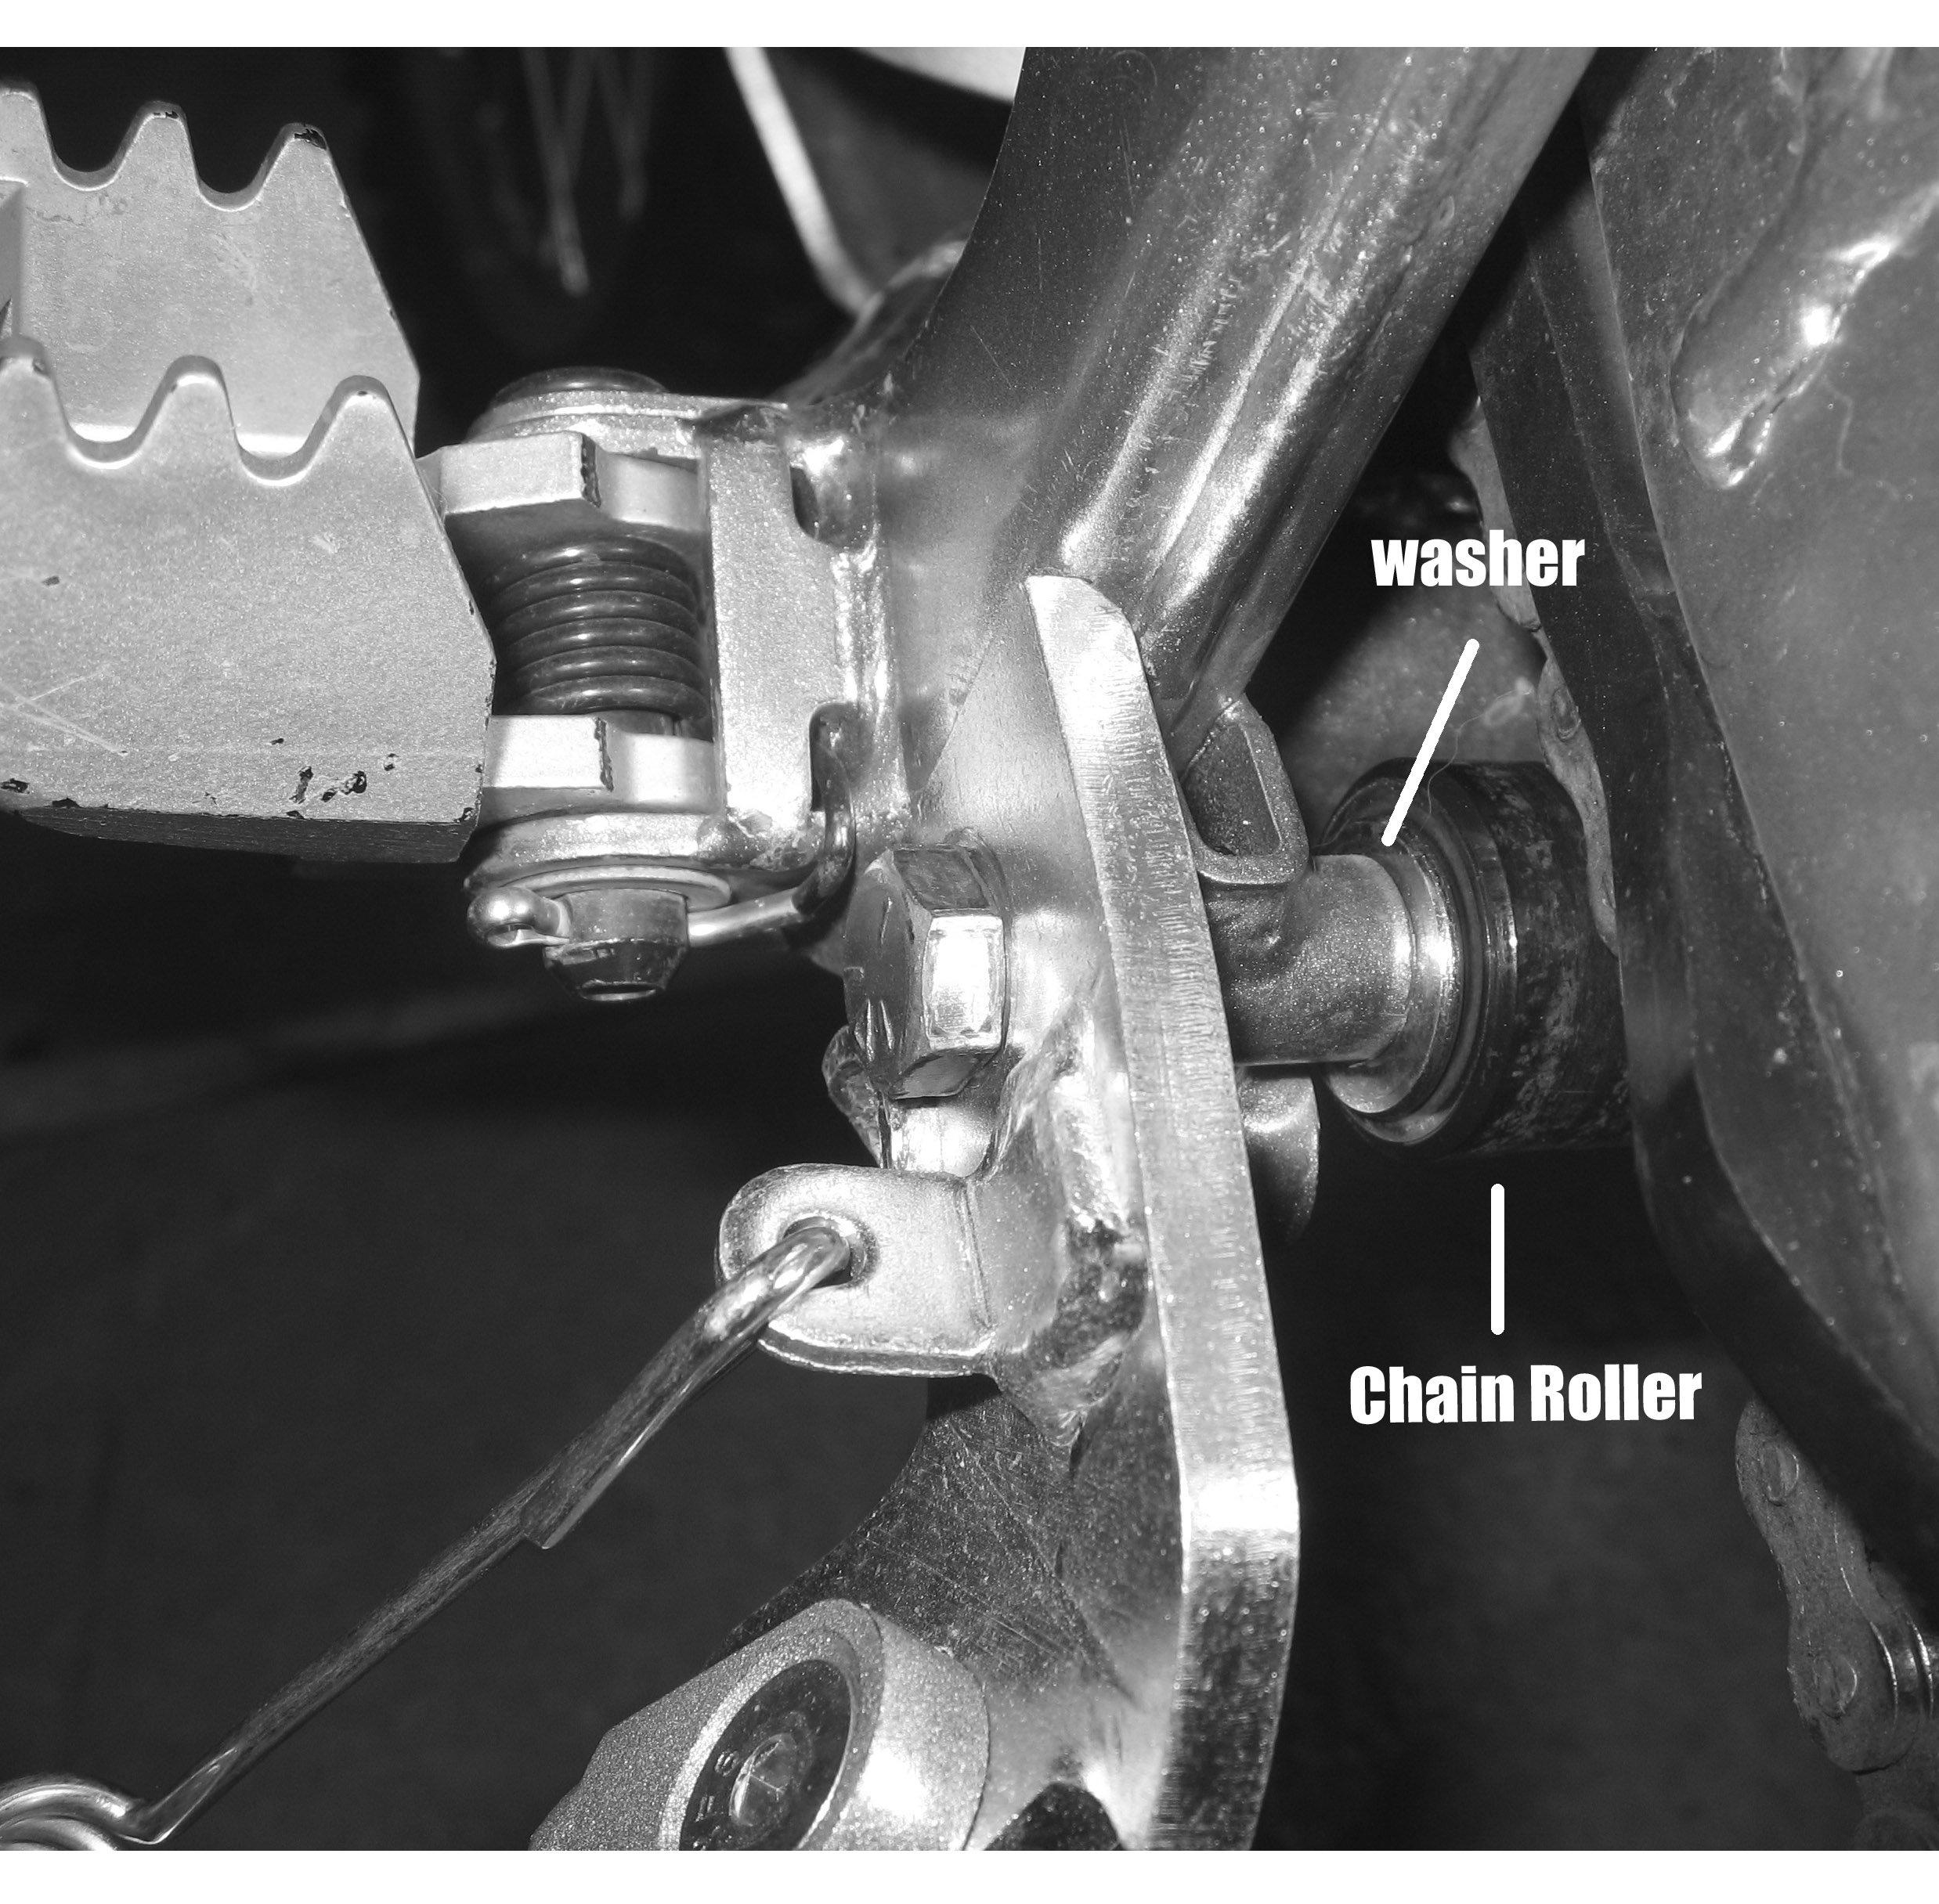
5. Tighten the nut and bolt.
6. Tighten the nut and bolt after the first ride and regularly after that.

